**Parole – Release and Eligibility – A Mud Map**

If the court imposes a sentence of more than three years imprisonment, a PED must be set, PSA s 160C.

*Chevathen v Queensland Police Service* [2016] QDC 270 : Where the period of parole is suspended by the parole board, the offender is at large and commits offences prior to apprehension, PRD as the offender was no “subject to parole” for that time – Noting that Long J in *R v Winkelmann* said this is not the correct approach.

*Rule v Commissioner of Police* [2016] QDC 64: Where the offender has remained in custody for an unbroken duration past the end of his liability under any prior sentence and thereafter solely, in pre-sentence custody for the offences for which the Court is to sentence, that sentence, including any declaration that the pre-sentence custody be taken as time served, may, at least in a practical sense, be viewed as being effected consecutively rather than in any overlapping, or it might be further observed connected, sense

*R v Braeckmans* [2022] QCA 25

*R v Nagy* [2004] 1 Qd R 63

*R v Pepper* (1999) 104 A Crim R 135

*R v Smith* [2015] 1 Qd R 323

*R v Wilson* [2022] QCA 18: in 2020 the changes to pre-sentence custody that not allows a court to declare time spent that attaches to more than the charges before the court and that “there is no preferred or prima facie position” as to the declaration of the pre-sentence custody to which s 159A(1) is now applicable, having regard to the remaining provisions in that section.

[*R v Winkelmann* [2022] QDC 49](https://archive.sclqld.org.au/qjudgment/2022/QDC22-049.pdf)*:* Examines the operation of sections the interpretation of “term” and “period” of imprisonment. Ultimately concluding that if the liability to serve a term under a parole order has lapsed, and no time is declared sharing and attaching to the expired liability (for a three year, no SVO or SA)

*Fact Patterns – sentences of three years or less where not a Sexual Offence, Serious Violent Offence or Terrorism Offence:*

* Offences committed while there are no existing parole orders, received a sentence of 3 years or less = **PRD** - PSA s 160B(3)
* Offences committed whilst subject to Court ordered parole = PED - PSA s 160B(2)
* Offences committed whilst subject to Board ordered parole = PRD – PSA s 160B(3)

Offences Committed whilst in the community, but after parole is suspended by the parole board but before apprehended and returned to custody.

**PSA 160D Sentence for a serious violent offence or sexual offence**

* **Serious Volent Offence**
* **Sex Offence**
* **Court must fix PED (date fixed must not be earlier than existing RPD or PED)**

**PSA 160C Sentence of more than 3 years and not a serious violent offence or sexual offence**

* **Not a Serious Volent Offence**
* **Not a Sex Offence**
* **Imprisonment for more than three years**

**If has current PRD = Court must fix PED (Date fixed must not be earlier than existing PRD)**

**If has current PED = Court must fix PED (Date fixed must not be earlier than existing PED)**

**If neither of the above = Court must fix PED**

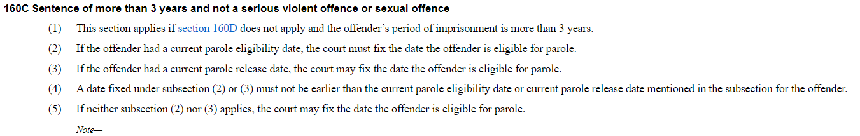

**160B Automatic cancellation of parole release or eligibility dates**

* Sentences to 3 years or less
* Not a SVO or Sex Offence
* Court fixes PRD

OR

* Sentences to 3 years or less
* Not a SVO or Sex Offence
* Court ordered parole cancelled by the Board (s 205 Corrective Serviced Act)
* Court ordered parole cancelled by operation of law (cancelled due to sentence of imprisonment being imposed s 209 Corrective Serviced Act)
* Court fixes PED

*However PED (not before any existing liability for PRD/PED) to be fixed if:*

* Subject to a Cth Control Order (Terrorism offences)
* Convicted of a terrorism offence:
  + terrorism offence under the Crimes Act 1914 (Cwlth)
* an offence against the repealed Crimes (Foreign Incursions and Recruitment) Act 1978 (Cwlth), sections 6 to 9
* an offence against the Terrorism (Community Protection) Act 2003 (Vic), section 4B
* an offence against the Crimes Act 1900 (NSW), section 310J
* an offence against the Criminal Law Consolidation Act 1935 (SA), section 83CA
* another offence against a provision of a law of the Commonwealth or another State if the provision:
* is prescribed by regulation; and
* is in relation to an activity that involves a terrorist act, or is preparatory to the carrying out of an activity that involves a terrorist act.

160B Sentence of 3 years or less and not a serious violent offence or sexual offence

(1)This section applies if neither section 160C nor 160D applies.

(2)If the offender has had a court ordered parole order cancelled under the Corrective Services Act 2006, section 205 or 209 during the offender’s period of imprisonment, the court must fix the date the offender is eligible for parole.

(3)If subsection (2) does not apply, the court must fix a date for the offender to be released on parole.

(4)However, the court may fix the date the offender is eligible for parole, instead of a date for the offender to be released on parole, if—

(a)the offender has, at any time, been convicted of a terrorism offence, whether or not the conviction has been recorded; or

(b)the offender is the subject of a Commonwealth control order; or

(c)the court is satisfied the offender has—

(i)carried out an activity to support the carrying out of a terrorist act; or

(ii)made a statement in support of the carrying out of a terrorist act; or

(iii)carried out an activity, or made a statement, to advocate the carrying out of a terrorist act or support for the carrying out of a terrorist act.

(5)To remove any doubt, it is declared that a reference in subsection (4)(c) to a terrorist act—

(a)includes a terrorist act that has not happened; and

(b)is not limited to a specific terrorist act.

(6)If the offender had a current parole eligibility date or current parole release date, a date fixed under subsection (2), (3) or (4) must not be earlier than the current parole eligibility date or current parole release date.

Note—

See also section 160F.

(7)Despite subsections (2), (3) and (4), the court must fix the date the offender is eligible for parole under subsection (8) if—

(a)the offender is sentenced to a term of imprisonment under section 161R(2); and

(b)in imposing the base component of the sentence under that section, the court would, apart from this subsection, be required to fix a date for the offender under subsection (2), (3) or (4).

Note—

Section 161R(2)(a) requires the court to impose a sentence of imprisonment for the offence of which the offender is convicted under the law apart from part 9D.

(8)The date the offender is eligible for parole is the day that is worked out by adding the relevant further period to the date the court would otherwise fix for the offender under subsection (2), (3) or (4) if the term of imprisonment imposed on the offender under section 161R(2) consisted only of the base component of the sentence imposed under that section.

(9)In this section—

Commonwealth control order means a control order as defined in the Criminal Code (Cwlth), section 100.1(1).

relevant further period, for an offender sentenced to a term of imprisonment under section 161R(2), means the period of the mandatory component of the sentence imposed on the offender under that section.

terrorism offence means—

(a)a terrorism offence under the Crimes Act 1914 (Cwlth); or

(b)an offence against the repealed Crimes (Foreign Incursions and Recruitment) Act 1978 (Cwlth), sections 6 to 9; or

(c)an offence against the Terrorism (Community Protection) Act 2003 (Vic), section 4B; or

(d)an offence against the Crimes Act 1900 (NSW), section 310J; or

(e)an offence against the Criminal Law Consolidation Act 1935 (SA), section 83CA; or

(f)another offence against a provision of a law of the Commonwealth or another State if the provision—

(i)is prescribed by regulation; and

(ii)is in relation to an activity that involves a terrorist act, or is preparatory to the carrying out of an activity that involves a terrorist act.

terrorist act see the Police Powers and Responsibilities Act 2000, section 211.

s 160B ins 2006 No. 29 s 497 (amd 2006 No. 41 s 35B (4))

amd 2016 No. 62 s 278; 2019 No. 10 s 23

**160E Automatic cancellation of parole release or eligibility dates**

The offenders parole release/eligibility date is automatically cancelled when:

* Court fixes a new PED or PRD
* Imposes imprisonment for SVO
* Imposed imprisonment for Sex Offence
* Where the period of imprisonment would exceed 3 years.

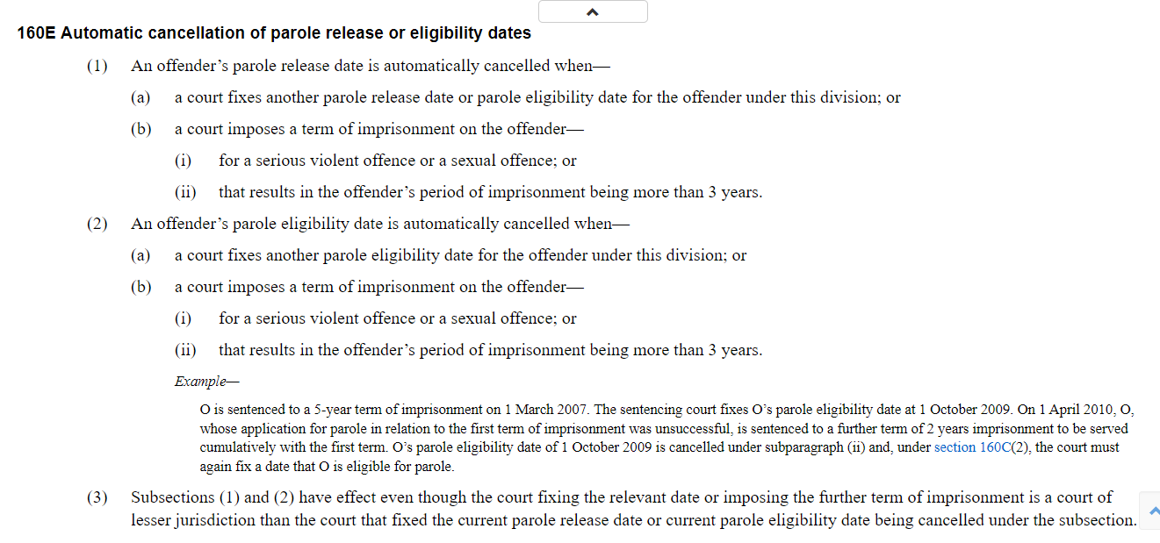

**Serious violent offences**

**PSA 161A, where the defendant is convicted of any of the below, or an attempt to commit one of the below, and is sentenced to 10 or more years, the SVO is automatic. If the defendant is sentenced to more than 5 but less than 10 years, the court may declare it as an SVO – PSA s 161B.**

**CC Offences under PSA Schedule 1:**

61 (Riot)

75 (Threatening violence)

142 (Escape by persons in lawful custody)

210 (Indecent treatment of children under 16)

213 (Owner etc. permitting abuse of children on premises)

215 (Carnal knowledge with or of children under 16)

216 (Abuse of persons with an impairment of the mind)

217 (Procuring young person etc. for carnal knowledge)

218 (Procuring sexual acts by coercion etc.)

 219 (Taking child for immoral purposes)

222 (Incest)

229B (Maintaining a sexual relationship with a child)

229G(1) (Procuring engagement in prostitution), if section 229G(2) applies

 236(2) (Misconduct with regard to corpses)

303 (Definition of *manslaughter*) and 310 (Punishment of manslaughter)

306 (Attempt to murder)

309 (Conspiring to murder)

313 (Killing unborn child)

315 (Disabling in order to commit indictable offence)

316 (Stupefying in order to commit indictable offence)

317 (Acts intended to cause grievous bodily harm and other malicious acts)

317A(1) (Carrying or sending dangerous goods in a vehicle)

318 (Obstructing rescue or escape from unsafe premises)

319 (Endangering the safety of a person in a vehicle with intent)

320 (Grievous bodily harm)

320A (Torture)

321 (Attempting to injure by explosive or noxious substances)

321A (Bomb hoaxes)

322 (Administering poison with intent to harm)

323 (Wounding)

324 (Failure to supply necessaries)

326 (Endangering life of children by exposure)

328A (Dangerous operation of a vehicle)

339 (Assaults occasioning bodily harm)

340 (Serious assaults)

349 (Rape)

350 (Attempt to commit rape)

37section 351 (Assault with intent to commit rape)

38section 352 (Sexual assaults)

39section 354 (Kidnapping)

40section 354A (Kidnapping for ransom)

40Asection 364 (Cruelty to children under 16)

41section 411(1) (Punishment of robbery)

42section 411(2) (Punishment of robbery)

43section 412 (Attempted robbery)

43Asection 417A (Taking control of aircraft)

44section 419(1) (Burglary), if section 419(3)(b)(i) or (ii) applies