Key Sources of law & Guidance
- Corners Act
- State Coroners Guidelines - https://www.courts.qld.gov.au/__data/assets/pdf_file/0011/206210/osc-state-coroners-guidelines-outline.pdf

General Purpose
The primary purpose of an inquest is to inform the family and the public about the matters required by s 45 of the Coroners Act 2003, including how the person died and what caused the person to die. A coroner is not able to include in the findings or any comments or recommendations any statement that a person is, or may be, guilty of an offence or civilly liable. Under the Coroners Act 2003, coroners are responsible for investigating reportable deaths that occur in Queensland. The investigation determines the identity of the deceased person, how they died, and the place, date and medical cause of the death.
What triggers a coronial inquest?
Inquests are not held for every death, however for certain deaths i.e. deaths in custody, an inquest is required. The focus is on determining what happened, not attributing blame, and making recommendations to prevent similar deaths in future. A reportable death is where:
- The person’s identity is unknown
- The death was violent or unnatural
- The death happened in suspicious circumstances
- A ‘cause of death’ certificate hasn’t been issued and isn’t likely to be
- The death was related to health care
- The death occurred in care, custody or as the result of police operations.
At the end of the inquest the coroners seek to determine:
- Who the deceased person is;
- How the person died;
- The cause of the death;
- When the person died; &
- Where the person died.
Coroners
- Local Coroner (every Magistrate is a Corner)
- Deputy Corner (By appointment)
- State Coroner (By appointment)
Makeup of the Coronal Court
- Court: Magistrate acting / appointed as the Coroner
- Counsel: Counsel assisting (usually a lawyer in the department, their role is to assist the Coroner)
- Lawyer with leave for a person with an interest in the matter.
Things to be aware of for Defence Lawyers
- This is an inquest, not a court.
- Civil standard, not criminal.
- Your role, as a “defence” lawyer would be to protect your clients interests by attempting to limit your clients exposure though the ‘questions’ the inquest seeks to answer at a pre-inquest conference and then to limit exposure at the inquest.
- While the right protecting self-incrimination has a place, it can be over-borne by the coroner (perhaps this would be there the lawyer would be able to assist the coroner as to why it would not be in the public interest), balanced against that is evidence and derivative evidence is not admissible against the person.
- Unlike the usual role of defence lawyers to be cautious about the scope of instructions, full, frank and comprehensive disclosure by the client may be necessary (but may preclude you from acting in a trial if they are charged).
Who could be called to give evidence?
A person who has sufficient interest in the matter may be represented by a lawyer and may examine and cross-examine witnesses, and make submissions, at an inquest. If a person is charged in which the question of who caused the death becomes an issue, the inquest must not commence or be suspended.
Once a referral to the coroner has been made and the decision to hold an inquest has been reached, there may well be a ‘pre-inquest conference’, where the scope of the inquest is settled. The following matters are dealt with at the pre-inquest conference:
- Counsel Assisting opens the evidence, tenders the brief of evidence and discusses previously circulated issues and witness lists.

- Applications for leave to appear and limited leave to appear are determined

- Those granted leave to appear should be invited to make submissions regarding proposed issues and/or witnesses either at the pre-inquest conference or in writing within 14 days

- Counsel Assisting raises any outstanding material, for example witness statements, expert reports etc and timetables set for the production of this material, followed up with a Form 25

- Counsel Assisting makes submission as to venue and the need for a view and the coroner makes appropriate rulings

- Submissions about the making of non-publication orders under s41 of the Act are heard and determined
There is an obligation to assist the coroner with the investigation, it is a reasonable excuse not to answer a question if the answer would tend to incriminate the witness. The coroner can compel a witness to answer questions under s39 if the coroner is of the view it is in the public interest, however both the evidence any and derivate evidence can then not be used against the person. A coroner cannot comment on criminal or civil liability, however a coroner can refer information about an indictable offence to a prosecutor.
The CC is not bound by the rules of evidence, however procedural fairness applies, the standard of proof is on the balance of probabilities applying the Briginshaw scale.
As the inquest is not a trial, if a witness is to give oral evidence, they can have their statement with the and answer questions. As a practicality, ‘stop-watch’ orders may be made.
From the “bench book” it appears that towards the conclusion of the inquest, Counsel Assisting submissions should foreshadow any adverse findings or comments, preventative recommendations or s48 referrals open to the coroner. Submissions should be made at the end of the oral evidence, and where possible the inquest should be adjourned with the parties to have access to the transcript, written submissions should be tendered to allow the coroner to consider any relevant non-publication orders.

Basic steps in the inquest
- The death is reported to the coroner, usually by police who attend the scene and get initial information about the death from family members, friends and witnesses. The coroner is notified of the death by a police report (Form 1) or medical professional (Form1A).

- The deceased is transported to a mortuary - police arrange for the government-contracted funeral director to take the deceased to a mortuary.

- The coroner orders an autopsy (if necessary) to help determine how and why the person died. The coroner considers family and cultural concerns before ordering an internal autopsy.

- Family may be contacted by Coronial Family Services – counsellors may contact you about the death and autopsy process.

- Family will be notified by the coroner - the senior next of kin will be advised by the coroner that the death is being investigated. Family will be updated throughout the investigation by a case manager.

- The deceased is released for burial or cremation – once the autopsy is complete and the body no longer needs to be kept for further examination or tests, it will be released into the care of the family’s funeral director. This usually occurs within 3-5 days. The coroner has the deceased person formally identified before releasing them to the family for the funeral. Police usually rely on a visual identification by someone who knows the person well. However, if that’s not possible, they use fingerprint, dental or DNA identification.

- Police help the coroner investigate the death – after reviewing the initial report of death the coroner may ask police to investigate further, possibly including getting medical records and further statements from witnesses. The coroner has wide powers of investigation, and can request additional reports, statements or information about the death. They may obtain more information from investigators, police, doctors, engineers, workplace health and safety inspectors, mining inspectors, air safety officers, electrical inspectors and other witnesses.

- Coroner completes their enquiries - once the coroner has completed their enquiries, they consider whether to hold an inquest (public hearing) into the death. The coroner consults with the family, who can also make a request for the coroner to hold an inquest.

- Coroner makes written findings - at the end of the investigation, the coroner makes written findings and sends a copy to the family. Most coronial investigations are finalised without an inquest.

S 39 Incriminating Evidence
(1) This section applies if a witness refuses to give oral evidence at an inquest because the evidence would tend to incriminate the person.
(2) The coroner may require the witness to give evidence that would tend to incriminate the witness if the coroner is satisfied that it is in the public interest for the witness to do so.
(3) The evidence is not admissible against the witness in any other proceeding, other than a proceeding for perjury.
(4) Derivative evidence is not admissible against the witness in a criminal proceeding.
(5) In this section— derivative evidence means any information, document or other evidence obtained as a direct or indirect result of the evidence given by the witness. proceeding for perjury means a criminal proceeding in which the false or misleading nature of the evidence is in question.

S 45 Coroners Findings
(1) A coroner who is investigating a suspected death must, if possible, find whether or not a death in fact happened.

(2) A coroner who is investigating a death or suspected death must, if possible, find—
(a) who the deceased person is; and
(b) how the person died; and
(c) when the person died; and
(d) where the person died, and in particular whether the person died in Queensland; and
(e) what caused the person to die.

(3) However, the coroner need not make the findings listed in subsection
(2) if—
(a) the coroner is unable to find that a suspected death in fact happened; or
(b) the coroner stops investigating the death under section 12 (2) .
(4) The coroner must give a written copy of the findings to—
(a) a family member of the deceased person who has indicated that he or she will accept the document for the deceased person’s family; and
(b) if an inquest was held—any person who, as a person with a sufficient interest in the inquest, appeared at the inquest; and
(c) if the deceased person was a child—
(i) the family and child commissioner; and
(ii) the chief executive (child safety); and
(d) if the coroner is not the State Coroner—the State Coroner.

(5) The coroner must not include in the findings any statement that a person is, or may be—

(a) guilty of an offence; or
(b) civilly liable for something.

(6) This section applies whether or not an inquest is held.

S 36 Leave to Appear
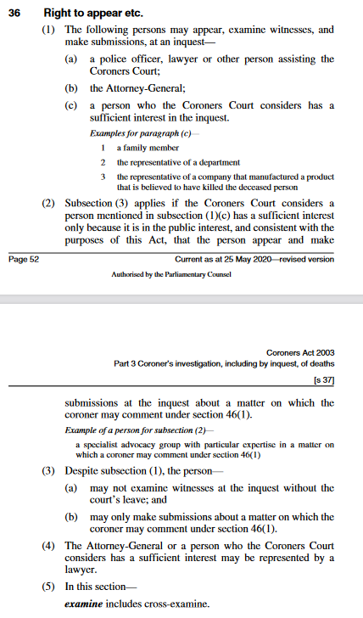

S 29 When inquest must not be held or continued
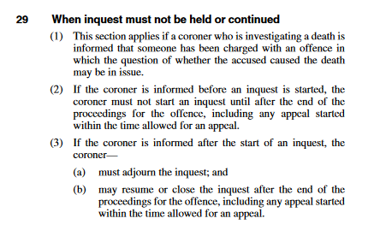

S48 – Power to refer information to a Prosecutor

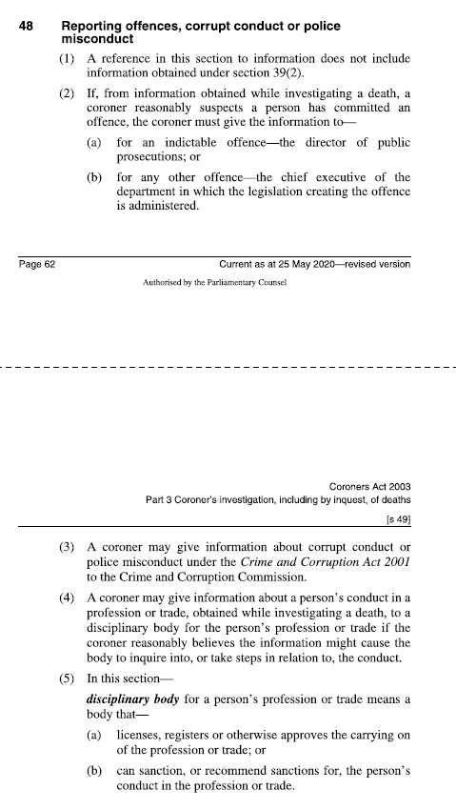

S 45 What the Coroner has the power to find
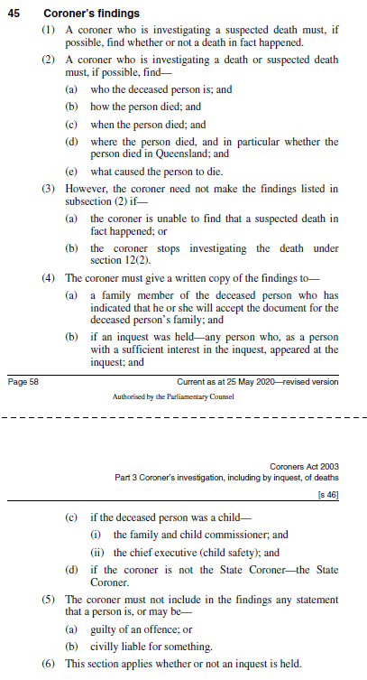

S 46 Coroners Comments
(1) A coroner may, whenever appropriate, comment on anything connected with a death investigated at an inquest that relates to—
(a) public health or safety; or
(b) the administration of justice; or
(c) ways to prevent deaths from happening in similar circumstances in the future.
(2) … omitted .. forwarding of the comments
(3) The coroner must not include in the comments any statement that a person is, or may be—
(a) guilty of an offence; or
(b) civilly liable for something.

Garbage Notes –

Coronial Inquests
Resources:
Corners Act / Guidelines –
State Coroners Guidelines - https://www.courts.qld.gov.au/__data/assets/pdf_file/0011/206210/osc-state-coroners-guidelines-outline.pdf

Sources of law
Coroners Act 2003
- S 24(1) – Scope? (old act from 1958) – now section 34 – Pre-Inquest Conference:
  - The Coroners Court may hold a conference before holding an inquest to decide”:

- 27 – When inquests are to be made.
- S 29 – If an inquest starts, and a person in then charged with in offence where an issues the person charged may have caused the persons death, the inquest must not be held or continue.
- S 45 – findings?
- S 46 – Preventative recommendations?
- S 16 – Duty to help the investigation, where the coroner sees fit (within the powers of the section) the person must assist (noting (6), it is a reasonable excused not to help the coroner is complying would tend to incriminate the person).
Purpose
The primary purpose of an inquest is to inform the family and the public about the matters required by s 45 of the Coroners Act 2003, including how the person died and what caused the person to die. A coroner is not able to include in the findings or any comments or recommendations any statement that a person is, or may be, guilty of an offence or civilly liable.
At the end of the inquest the Coroners seeks to determine:
- Who the deceased person is;
- How the person died;
- The cause of the death;
- When the person died; &
- Where the person died.

Rules of evidence
Section 37 – Not bound by the rules of evidence.
S 39 – Incriminating evidence:
Coroner may compel a witness to give incriminating evidence if the Coroner is satisfied it is in the public interest to do so. The evidence can only be used against the person for a perjury charge. Derivative evidence is not admissible against the witness in a criminal proceeding (defined as means any information, document or other evidence obtained as a direct or indirect result of the evidence given by the witness.)
Procedural notes / questions:
- 28 days notice of a hearing must be published.
- Must be held in open court unless the coroner orders the court be closed while particular evidence is given (s 31).
- Who and how in a CI commenced?
- Pre-inquest hearing (where the issues of the inquest are determined?)
Right to appear s 36
- (a) A police officer, lawyer, or other person assisting the CC.
- The Attorney General
- A person who the CC considers to have a sufficient interest (there is a threshold test for this one).
- The person may not examine a witness without the leave of the court and only make submissions about a matter on which the court may comment under 46(1).

S 36(1)(c), sufficient interest is not defined in the Act, but Family Members and “Any person whose actions may have caused or contributed to the death, where there is a reasonable prospect that the coroner may make a finding or comment adverse to that person’s interest, see Barci v Heffey, unreported Supreme Court of Victoria, 1 February 1995.
S 36 (4).
S 36(1).
S 29.
S 34.
S 45(5)(b)
48(2), but does not include answers compelled under s 39.
S 37.
Harmsworth v State Coroner [1989] VR989 at 994. For discussion see Freckelton, I in the The Inquest Handbook, Selby H. (ed), Federation Rules, Sydney, 1998

